**World Quant University**

**Professor: Tiberiu Stoica**

**Econometrics**

Nikolas Lippmann Pareschi - [nikolaslippmann@gmail.com](mailto:nikolaslippmann@gmail.com)

**Mini Project: Implement CAPM Model in Python and Excel**

**Problem:  Implement CAPM Model in Python**

Stock return: Oracle  
Period: March 25, 2015 – June 25, 2015  
Source: A financial website such as Google Finance, Yahoo Finance, Quandl, CityFALCON, or another similar source  
Market return: S&P 500

1. Discuss the regression summary results provided by Python

I turned on PEP8 checker on Spyder to stick to the guidelines suggested in Python 2 classes. First we declared the global variables:

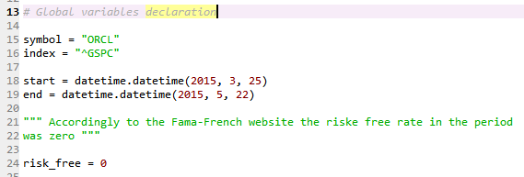

Then we did some treatment on data and applied the linear regression method using statsmodel api;

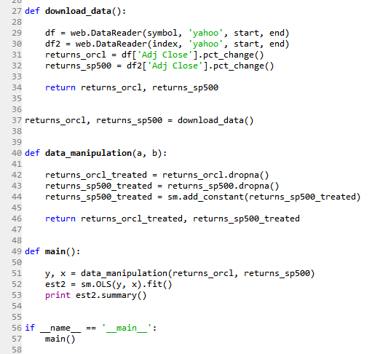

These were our results:

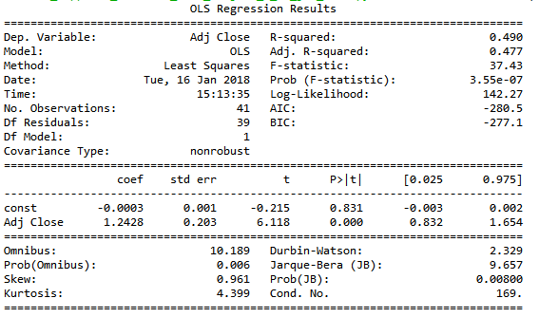

We had considering a risk free rate of zero, taken from Fama-Keneth website, a Beta of 1.2428 for ORCL and an Alpha of -0.0003. The stock performed worse than the market. But the period was too small, less than 3 months, so we cannot really affirm that Oracle will under perform in the future. It is necessary to say also that CAPM is a picture of the past, idiosyncratic conditions can change in the future.

1. Implement the same regression in Excel using Analysis ToolPak.

First we downloaded the data from yahoo and from Fama-French website:

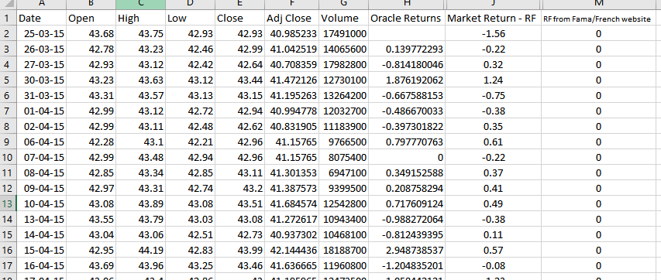

Then we performed the regression:

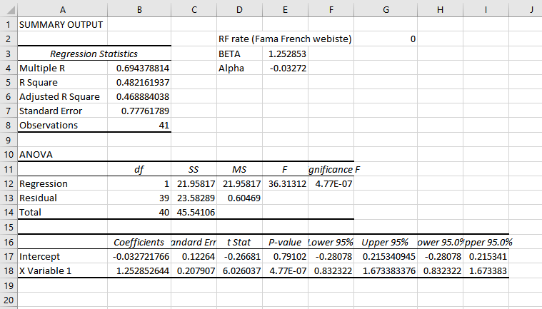

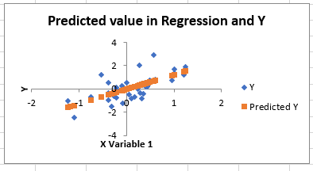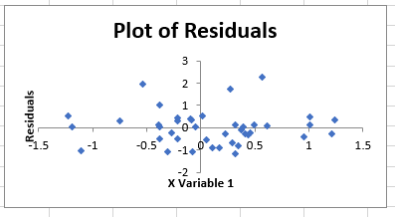

1. Discuss the results.

As one can see we got a Beta of 1.25285 in excel and a Beta of 1.2428 in Python. The alpha in excel was -0.032 and in Python it was -0.03. These differences occurred due to rounding differences in excel and Python:

Market returns – risk free of zero in Excel:

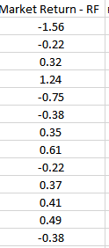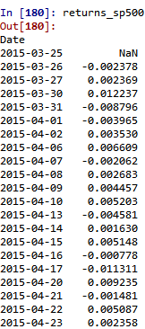

It is also important to say how the residuals were randomly distributed around 0. We expected this to be true. Abou the negative alpha, as previously said, the CAPM model was implemented in a small sample of 3 months. It is necessary to say also that CAPM looks into the past. Idiosyncratic conditions can change in the future.